**Brooklyn torah gazette**

**For parshas ki sisa 5782**

Volume 6, Issue 22 (Whole Number 277) 18 Adar I 5782/ February 19, 2022

**Printed L’illuy nishmas Nechama bas R’ Noach, a”h**

For a free subscription, please forward your request to [***keren18@juno.com***](mailto:keren18@juno.com)

**Why Are Stillborns'**

**Graves Unmarked?**

**By Rabbi** [**Yehuda Shurpin**](https://www.chabad.org/search/keyword_cdo/kid/15169/jewish/Shurpin-Yehuda.htm)



Losing a child of any age is heart-wrenching, and I would encourage anyone who unfortunately is experiencing this to explore [some of our articles](https://www.chabad.org/search/keyword_cdo/kid/10335) on the topic. While the following is meant to focus on the specific question asked, I hope that it offers some perspective as well.

It is important to note that although the term “stillborn” is usually defined as a child who was born without life, from a halachic perspective, it would also include a baby who was born prematurely and then died. The Hebrew term for both of these is *nofel*. Or Nefel. Practically, since it is usually hard to know whether a child is considered to have been born “prematurely” from a halachic perspective, this includes any baby who, G‑d forbid, passes away within the first 30 days of life.

In general, a baby who dies within 30 days needs to be buried,[1](javascript:doFootnote('1a5390113');) albeit without the usual funeral and mourning rituals. None of the liturgies of the burial service, including Kaddish, are recited.

There are, however, specific laws that pertain to the burial of this child, which are taken care of by the *[chevra kadisha](https://www.chabad.org/library/article_cdo/aid/4107711/jewish/The-Chevra-Kadisha.htm" \o "The Chevra Kadisha)* (Jewish burial society). This includes giving the baby a name, as well as circumcising the baby if need be. The baby is buried privately, usually with just three people from the burial society present. Generally, even the family is not in attendance.[2](javascript:doFootnote('2a5390113');)

One of the reasons for this is that until quite recently, the rate of neonatal death was quite high. In the Middle Ages, parents anticipated many pregnancies, fully aware that a high percentage of the babies would not survive. As sad as miscarriages and stillbirths were, the family and the community knew of the risks and expected a certain amount of loss.

The rabbis were aware of this as well. Thus, the predominant position of Jewish law was that if a baby did not survive for 30 days, it was as if the baby had not lived.[3](javascript:doFootnote('3a5390113');)

Although the child was buried, there was no funeral per se, the grave was left unmarked, and the parents might never know where the grave was located. It was considered an act of kindness to the parents and the community, for without the restriction, families would have been in mourning almost continuously.

(Note: Since times have changed and stillbirths have, thank [G‑d](https://www.chabad.org/library/article_cdo/aid/433240/jewish/God.htm), become a somewhat rarer occurrence, there are some communities in which the parents attend the burial. One should consult with one’s rabbi and/or the local burial society.)

**The Resurrection of the Dead**

Although, as mentioned, there is no funeral or mourning, we are still careful to bury the child. One reason for this stems from the cardinal Jewish belief that the soul is eternal.[4](javascript:doFootnote('4a5390113');) When people pass away, their souls continue on in the afterlife, and eventually, in the messianic era, the dead will be resurrected and reunited with their loved ones.

This applies even to a stillborn baby. It is for this reason that a stillborn is named by the *chevra kadisha* and is even circumcised post-mortem (for more on this, see [Post-mortem Naming and Circumcision for a Stillbirth](https://www.chabad.org/library/article_cdo/aid/2432015/jewish/Post-mortem-Naming-and-Circumcision-for-a-Stillbirth.htm)).

The Zohar explains that proper burial in the ground is conducive to the resurrection process and a reflection of belief in the resurrection of the dead.[5](javascript:doFootnote('5a5390113');)

**Why Were These Souls Born?**

There are esoteric reasons why a soul must briefly enter this world in such a fashion, usually related to the loftiness of the soul.[6](javascript:doFootnote('6a5390113');)

This soul was not here long enough to be mourned or even to come into contact with (and perhaps be tainted by) the physicality of this world. So [Kaddish](https://www.chabad.org/library/article_cdo/aid/514160/jewish/Mourners-Kaddish.htm) and anything else to “elevate” the soul aren't needed. At the same time, this is a lofty soul that will eventually be resurrected together with all the other souls, and as such we make sure to bury the child.

Furthermore, the Talmud[7](javascript:doFootnote('7a5390113');) states that Moshiach and the ultimate redemption will not come until there are no more souls in the heavenly storage house, and all the souls that are destined to come into this world have done so. This is accomplished even by souls such as these, which never fully lived.

Thus, we can take comfort in knowing that these souls took part in hastening the ultimate redemption and the coming of Moshiach.

May we merit the day when the words of the prophet Isaiah will finally be fulfilled: “Death shall be swallowed up forever, and G‑d shall wipe the tears from every face.”[8](javascript:doFootnote('8a5390113');)

**FOOTNOTES**

[1.](https://www.chabad.org/library/article_cdo/aid/5390113/jewish/Why-Are-Stillborns-Graves-Unmarked.htm" \l "footnoteRef1a5390113) *Shulchan Aruch, Yoreh De’ah* 263:5, 353:4; see also *Darkei Chesed* 18:4.

[2.](https://www.chabad.org/library/article_cdo/aid/5390113/jewish/Why-Are-Stillborns-Graves-Unmarked.htm" \l "footnoteRef2a5390113) See *Shulchan Aruch, Yoreh De’ah* 353:4; *Darkei Chesed* 18:5.

[3.](https://www.chabad.org/library/article_cdo/aid/5390113/jewish/Why-Are-Stillborns-Graves-Unmarked.htm" \l "footnoteRef3a5390113) *Mishneh Torah, Hilchot Aveilut* 1:6; *Shulchan Aruch, Yoreh De'ah* 374:8.

[4.](https://www.chabad.org/library/article_cdo/aid/5390113/jewish/Why-Are-Stillborns-Graves-Unmarked.htm" \l "footnoteRef4a5390113) The other reasons relate to the laws of impurity as well as the prohibition of having any benefit from the dead.

[5.](https://www.chabad.org/library/article_cdo/aid/5390113/jewish/Why-Are-Stillborns-Graves-Unmarked.htm" \l "footnoteRef5a5390113) See Zohar 1:116a, 3:177a.

[6.](https://www.chabad.org/library/article_cdo/aid/5390113/jewish/Why-Are-Stillborns-Graves-Unmarked.htm" \l "footnoteRef6a5390113) For a fascinating example of this (albeit about an infant, not necessarily a stillborn) see [The Reincarnated Prince](https://www.chabad.org/library/article_cdo/aid/102694/jewish/The-Reincarnated-Prince.htm).

[7.](https://www.chabad.org/library/article_cdo/aid/5390113/jewish/Why-Are-Stillborns-Graves-Unmarked.htm" \l "footnoteRef7a5390113) Talmud, Yevamot 62a.

[8.](https://www.chabad.org/library/article_cdo/aid/5390113/jewish/Why-Are-Stillborns-Graves-Unmarked.htm" \l "footnoteRef8a5390113) [Isaiah 25:8](https://www.chabad.org/15956#v8).

*Reprinted from the Parshat Tetzaveh 5782 email of Chabad.Org Magazine.*

**Thoughts that Count for Our Parsha**

*However, My Sabbaths you must observe* (31:13)

Shabbat is expressed in plural, because according to the Talmud, two angels accompany a person on his way home from the synagogue on Friday night. One angel is good, and the other is evil. When the angels enter the house and find a home filled with the Shabbat atmosphere and a table set with Shabbat candles and challah, the good angel blesses the family that they should merit the same spiritual atmosphere the next Shabbat. Reluctantly, the evil angel answers, "Amen." Thus, the proper observance of one Shabbat is a source of blessing to observe another Shabbat. (Malei Haomer)

*Reprinted from the Parshat Tissa 5757/1997 edition of L’Chaim. Adapted from Vedibarta Bam by Rabbi Moshe Bogomilsky.*

**Rabbi Berel Wein**

**On Parshas Ki Tisa**

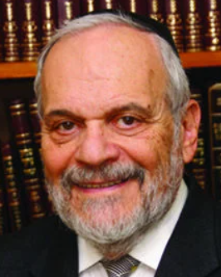

The sin of the Golden Calf remains one of the great mysteries in the story of the Jewish people throughout the ages. Flooded with miracles on all sides, unbelievably redeemed from Egyptian bondage, and being sustained daily in a desert, the Jewish people somehow revert to idolatry and paganism. As illogical as this is, it is, nevertheless, not as surprising as later generations may assess the events.

Human beings are not only influenced, but, to a greater extent, are limited and bound by the norms of the general society in which they exist. How can millions of North Koreans weep at the death of someone who was a tyrant and a murderer over them? Yet that is exactly what happened when the two previous Kingdoms finally passed from this earth. It is exceedingly difficult to maintain one's individual beliefs, no matter how correct and logical they may be, in the face of contrary opinion held by the majority general society.

There was a phrase in Yiddish and translates as "the general society is malleable and foolish". Even the most outlandish of ideas – such as paganism itself – somehow will gain traction, even amongst intelligent people, if it is somehow the prevailing attitude that permeates the general society. In a world of belief and sacrifice for paganism, it is not that difficult to understand that this should affect the Jewish people as well, in spite of their own personal and national history of monotheism, miracles and G-dly deliverance.

The Talmud records that one of the great rabbis of the time saw the wicked king Achov in one of his dreams. The Rabbi asked the tyrant for his help in answering a question in Jewish law, over which the rabbis of the study hall were struggling. The king answered promptly and correctly, as to what the law is according to Jewish tradition. The rabbi in wonderment asked the king that if he is such a scholar, how could he follow idolatry and allow it to  be rampant in the Jewish kingdom that he ruled? Achov answered: “If you would have lived in my generation, you would have picked up the hem of your robe in order to run more quickly to serve that false idol.”

We look back at so many false idols and beliefs that litter the landscape of human history, and especially those of Western civilization. We wonder how people could have been so naïve and foolish and so wrong about such basic matters of faith and perspective? Yet we ourselves live in a society dominated by what we realize to be false ideas, bad policies and the foolish denial of facts and realities, let alone the obvious lessons of history and tradition. We know, for instance, that cancel culture is wrong, evil, and counterproductive to the human spirit and belief. Nevertheless, we are all careful not to say and certainly not to publish what we know to be true, because of our trepidation that we will somehow be canceled because of it.

To be a Jew requires a great moral strength and fortitude. We have not always been able to swim against the current tide, and, tragically, we always pay a price for that failing.

*Reprinted from this week’s website of rabbiwein.com*

**More Thoughts for Our Parsha**

*When you take a census....every man shall give G-d an atonement for his soul....This they shall give....a half-shekel.* (Exod. 30:12-13)

Moshe could not understand how money can accomplish forgiveness for the soul. G-d showed Moshe a fiery coin which weighed a half-shekel, and He explained that a coin by itself cannot atone for a grave sin. However, if one gives with warmth and enthusiasm that comes from the fiery core of the Jewish soul, then a coin can truly become the cause of forgiveness. (Likutei Sichot)

*Reprinted from the Parshat Tissa 5757/1997 edition of L’Chaim. Adapted from Vedibarta Bam by Rabbi Moshe Bogomilsky.*

**Rav Avigdor Miller on**

**Depression and Sleep**



**QUESTION:** **What should somebody do when he is annoyed by depression and sadness and doesn’t know what the reason is?**

**ANSWER:** I want to tell you one thing I do know from experience. Many times, boys in the yeshiva cause an upset in their nervous system because of a lack of sleep. In the dormitories you can’t go to sleep early. Even if he gets into bed, somebody comes in at 1 o’clock and doesn’t let him sleep.

I once told a man about this problem and he went and took his boy out and put him in a separate room. He was a wealthy man and he paid money to the dormitory for a separate room, so his son should be able to sleep.  
 It’s very important to sleep. I myself know two cases of boys who didn’t go to sleep on time and they went insane, nit eingedacht. Yes, it happened. They ruined their lives.

Also, married women who have babies, they must take care of their sleep. Without sleeping sufficiently your nervous system is upset.

Now, once a person gets into a depression it’s not so easy to get out of it. And therefore, an ounce of prevention is worth a pound of cure. So, try with all your efforts not to upset your system and get your sleep every night.

Now some people say, “Well, I’m a porush. I want to be a masmid.” We’ll, I’ll tell you what the Chofetz Chaim said. Once the Chofetz Chaim came into the yeshiva in Radin at night, and he saw boys learning late so he said to them “Gei shlufen. Morgen is oich a tug.” He told the boys to go to sleep. “You can learn tomorrow,” he said.

And that’s the sensible way. That’s saving the lives of people by advising them, “Learn by day and sleep at night.”

Now, sometimes there are other factors, but one of the most general factors that I know from my experience, is this one of not sleeping sufficiently.

*Reprinted from the February 9, 2020 email of Toras Avigdor. Adapted from Tape #E-10.*

**The First Rabbi in America: Rabbi Abraham Rice Part 3**

**By Dr. Yitzchok Levine**

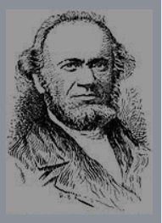

**Defender of Orthodoxy**

As mentioned above, not long after Rabbi Rice became the spiritual leader of Nidchei Yisroel, he faced opposition from those who wanted to introduce various reforms.

In 1842 some of those who felt that Rav Rice was too extreme in his insistence on maintaining halachic standards left his congregation and founded the Har Sinai Verein (Society).

The first Rosh Hashana services held by this congregation “featured” hymns sung to the accompaniment of an organ. This temple became the first lasting Reform congregation in America. The founding of the Har Sinai Verein marked the beginning of the emergence of the Reform movement as a major force in American Jewry during the nineteenth century.

The Reform movement eventually launched an all-out attack on traditional Judaism, and Rabbi Rice became an eloquent defender of Orthodoxy. His most unique contribution, however, was his defense of Orthodox Judaism in America.

**A Painful State of Affairs**

Where there were so few real scholars, it was easy for pseudo-intellectuals to misinterpret the basic principles of Jewish theology and thus pave the way for the spokesmen of Reform Judaism. This state of affairs was very painful to Rabbi Rice, and he went out of his way to challenge these “erroneous doctrines” as he called them, and to set the record straight.

A short time after his arrival in the United States, when English was still foreign to him, he came to the defense of the Talmud in a letter to the editor of Occident."

As one of the few Orthodox rabbis in America, Rabbi Rice emerged as an important defender of tradition in the face of religious Reform. Criticizing Reform clergy, Rabbi Rice excommunicated Isaac M. Wise, a leading Reform clergyman, for questioning aspects of the traditional Jewish belief of messiah and resurrection.

While his polemics against Reform failed to curtail the growth of Reform Judaism in America, his remarks reflected the concerns of Orthodox Jews regarding the preservation of Jewish tradition in America."

**A Close Friend of Isaac Leeser**

Rabbi Rice became a close friend of Isaac Leeser, the Philadelphia Chazzan who was in the forefront of everything Orthodox in the United States during the nineteenth century." In addition to writing articles that Chazzan Leeser published in his monthly Occident and Jewish Advocate, Rabbi Rice urged him to undertake an authoritative English translation of the Bible, pointing out that the German translations then available did not appeal to the English-speaking Jewish youth of America.

**Qualified to Deal**

**With Halachic Issues**

The result was a magnificent piece of work written in accordance with Orthodox Judaism that became a standard for decades. Leading Posek Rabbi Rice was one of the few men in America during the mid-nineteenth century who was qualified to deal with halachic issues.

He received inquiries from Jewish communities throughout the United States about many matters. Given his personal modesty, he was reluctant to assume responsibility for making decisions on important religious matters.

However, he realized that the people had virtually no one else to turn to. His detailed responsa were written in the typical style of the poskim of his time.

**He Approved of**

**West Indian Esrogim**

In response to a question about the use of West Indian esrogim, he replied in the affirmative. He dealt with the kashrus of the food additive shortening and the oils used in its manufacture, the proper way to write gittin in U.S. cities where a get had never been written before, the drawing of blood from animals immediately before shechita (This was thought at the time to have a beneficial effect on the meat), and many other issues.

**His Talmudic Scholarship**

**And Personal Reputation**

Rabbi Rice’s Talmudic scholarship and personal piety earned him a reputation as one of the few noteworthy scholars of Jewish law in America during the mid-nineteenth century.

By responding to religious queries from congregations throughout the United States regarding matters of family law, Sabbath observance, and

kashrut, Rabbi Rice offered direction to the small community of American Jews eager to preserve Orthodox tradition.

In 1844, for example, Rabbi Rice was asked by a congregation in Philadelphia to advise them regarding the correct manner of installing a plumbing system for the construction of a new mikvah.

Several years later, he responded to queries from a New York congregation seeking to clarify procedures for the burial of uncircumcised children or individuals who married contrary to Jewish law." Continued iys next week.

*Reprinted from the Parshas Ki Sisa 5782 email of whY I Matter, Yedidye Hirtenfeld’s parsha sheet for the Young Israel of Midwood in Brooklyn.*

**Additional Thoughts that Count for Our Parsha**

*The Israelites shall keep Shabbat, to make the Shabbat an eternal covenant for their generations* (Exod. 31:16)

The word for "their generations," "ledorotam," can also be read "ledirotam," which means "their dwelling places." The Torah is teaching us that the Jewish people should strive to make the Shabbat beautiful and majestic in their homes. (Iturei Torah)

*Aharon announced, "Tomorrow there will be a festival to G-d."* (Exod. 32:5)

The golden calf was made on the sixteenth day of the month of Tammuz, and on the seventeenth of Tammuz Moshe came down from heaven. Upon seeing the golden calf, he broke the tablets. Many years later, also on the seventeenth day of Tammuz, our enemies penetrated the wall that surrounded Jerusalem and proceeded to destroy the Holy Temple.

Since then, the seventeenth day of Tammuz has been a fast day, but the prophet Zecharya tells us that when Moshiach comes, the seventeenth of Tammuz will be a day of rejoicing. This is the festival that Aharon is referring to, the future holiday of the seventeenth of Tammuz, which, after Moshiach comes, will be "a festival to G-d." (Mayana Shel Torah)

*Reprinted from the Parshat Tissa 5757/1997 edition of L’Chaim. Adapted from Vedibarta Bam by Rabbi Moshe Bogomilsky.*

**The Importance of Emulating G-d’s Patience for the Sinning Jew**

**From the Talks of the Lubavitcher Rebbe**

**Rabbi Menachem Mendel Schneerson, Zt”l**

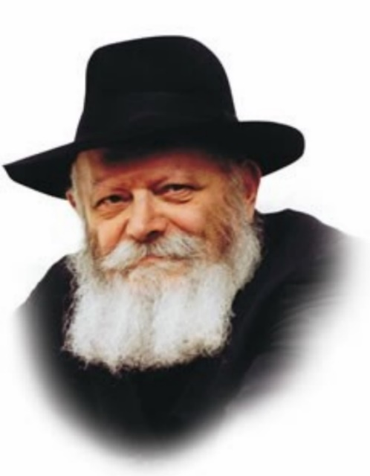

This week's Torah portion, Tissa, relates that G-d gave Moshe the Tablets of the Law as soon as He finished teaching him the Torah -- on the fortieth day after Moshe ascended Mount Sinai. The purpose of teaching the Torah to Moshe was that he, in turn, would impart it to the Jewish people; the Tablets were likewise to be given to the Jewish people.

What were the Jews doing while Moshe was on Mount Sinai? As we learn in this week’s portion, on the thirty-ninth day of Moshe's absence the Jewish people made the Golden Calf, a very serious sin.

Thus, we see that despite their sin, G-d continued to learn Torah with Moshe so he could teach it to the Jews. G-d gave Moshe the Tablets after they had made the Golden Calf.

From this we derive a very important lesson about how to relate to other people.

**G-d Didn’t Stop Teaching Torah to**

**Moshe Even After the Jews Transgressed**

G-d did not stop teaching Moshe when the Jews transgressed. On the contrary, He continued learning with him until the entire Torah had been taught, and even gave him the Tablets of the Law.

We too must emulate G-d's actions. If we want to have a positive influence over another person, that they strengthen their observance of Torah and its commandments, the other person's spiritual standing is irrelevant. It is forbidden to stop teaching someone Torah or cease trying to bring him closer to Judaism even if he continues to sin, G-d forbid. On the contrary, we must try even harder to exert a positive influence. And when we do, both the "giver" and the "taker" will surely benefit. Indeed, G-d acted in the same manner even when it came to the destruction of the Holy Temple.

**Why G-d Refrained from Destroying**

**The Temple for Many Years**

The Temple in Jerusalem was destroyed because of the sins of the Jewish people. And yet, the Jewish people were sinning for a long time before it was actually destroyed. Despite their transgressions, G-d refrained from taking this drastic step for many years.

Why? G-d wanted the Holy Temple to continue to exist for as long as possible. Although the Jews were sinning, He gave them ample opportunity to repent and prevent the destruction from occurring.

We too must always help our fellow Jew to preserve the spiritual Temple in his heart. We must never withhold spiritual aid and assistance. Even if the other person does not conduct themselves properly and sins, we must always continue to fortify their spiritual Sanctuary. In this manner we will merit the building of both the spiritual Sanctuary that exists within every Jew, as well as the Third Holy Temple by Moshiach, speedily in our day.

*Reprinted from the Parshat Tissa 5757/1997 edition of L’Chaim. Adapted from Likutei Sichot Vol 11.*

**Shtladlanim: Stephen Klein**

**By Rochel Licht**

[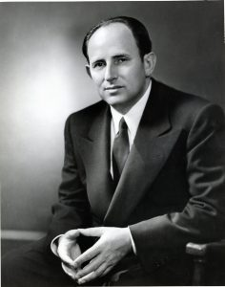](https://jewishaction.com/content/uploads/2021/11/Klein1-scaled.jpg)

**Stephen Klein *-* Courtesy of BMG Archives**

In 1938, after the Anschluss, the annexation of Austria into Nazi Germany, Stephen Klein (1907-19780 fled Austria and settled in New York. Having been in the chocolate business in Vienna, in New York he founded Barton’s Candy Corporation (initially known as Barton’s Bonbonniere), which produced deluxe kosher chocolate.

Almost unheard of at the time, Barton’s, a major retail company with more than several dozen stores, was closed for Shabbos and Jewish holidays. (By the time Klein passed away in 1978, the company had gone public with 3,000 stores across the country.)

Furthermore, Barton’s proudly listed Sabbath candle lighting times in the New York Times and other major newspapers. Klein, as a recently arrived refugee, demonstrated that even in America, economic success does not preclude commitment to Torah observance. Almost single-handedly, he had begun to change the American Jewish narrative.

**Devoted Great Efforts to Securing Visas and Sponsorships for Family Members and Friends in Europe**

Hearing of Nazi attacks on Jews in Vienna and other European countries, Klein devoted great efforts to securing visas and sponsorships for family members and friends desperately seeking emigration.

He joined the Vaad Hatzalah and became one of its major activists. He provided financial support, raised funds and used his business connections to open doors to government leaders.

With the arrival of Rav Aharon Kotler to New York in 1941, Klein became the rosh yeshivah’s devoted disciple.

“I never saw such a relationship of total devotion by a philanthropist and lay leader to a rosh yeshivah as that of Stephen Klein to Hagaon Rav Aharon Kotler,” said the well-known late Jewish communal leader Dr. Marvin Schick. “He followed Rav Aharon’s orders like a servant. He did not always agree with him, but he complied with his requests with all his heart and resources.”1

On numerous occasions, Klein joined Rav Kotler and other rabbinic leaders in Washington, DC, to intercede with government officials for the rescue of European Jews.

**Klein, as a recently arrived refugee, demonstrated that even in America, economic success does not preclude commitment to Torah observance.**

After the war, the Vaad Hatzalah expanded its activities to aid the she’erit hapleita, the survivors in DP camps. As chairman of the Vaad Hatzalah Immigration Committee, Klein was deeply concerned about the welfare of the survivors and their transfer out of Europe.

In 1946, he traveled to Europe as an officer of the United Nations Relief and Rehabilitation Administration (UNRRA), leaving his family and business behind.

During his six-month trip, he visited a number of DP camps and devoted significant time to arranging visas and documents for thousands of refugees. Aware of the importance of the survivors’ religious recovery, he helped establish kosher kitchens, schools and yeshivos, and distributed much-coveted religious books and ceremonial articles. In France, Klein helped establish five children’s homes, where orphans were cared for and educated.

When he returned to New York, his work didn’t stop. He was determined to raise awareness of the survivors’ dire situation and to assist as many survivors as possible.

**His Company Had an**

**Office of Immigration**

A 1952 article in Commentary refers to an office in Klein’s company known as the “Office of Immigration,” which was dedicated to attending to the “various technical details for bringing over Jewish displaced persons from Europe.” The article states that [as of 1952], “some fifteen hundred persons have come to America through Klein’s aid.”2

“Stephen Klein had a way of listening to people . . . it did not matter how busy he was . . . and focusing only on you,” said Rabbi Joseph Baumol, founder of the Yeshiva of Crown Heights in Brooklyn. “When someone came to him with a problem, regardless of who it was, he would listen to every word and genuinely try to help.”3

[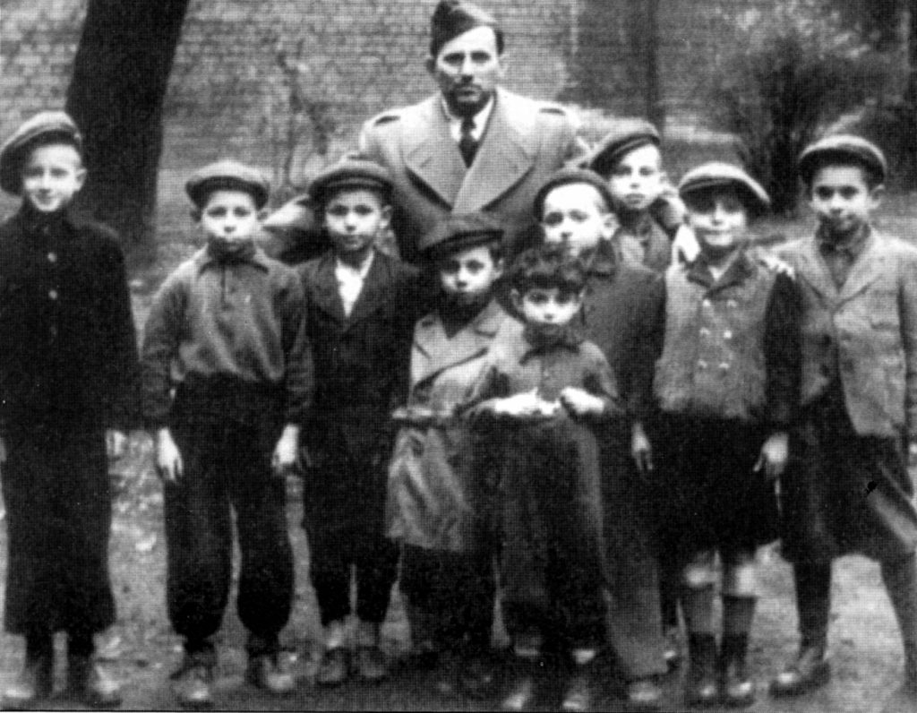](https://jewishaction.com/content/uploads/2021/11/Klein2.jpg)

**Stephen Klein pictured with group of children who were hidden during the Holocaust during his trip to Europe as an officer of the United Nations Relief and Rehabilitation Administration (UNRRA) in 1946. Photo courtesy of BMG Archives**

Throughout his communal activities, Klein was involved in supporting Jewish education. Even in his business life, Klein, who was innovative and forward thinking, found ways to educate his Jewish consumers by including attractive and informative pamphlets about the upcoming Jewish holiday in his chocolate gift boxes.

Klein was vice president of Torah Umesorah/the National Society for Hebrew Day Schools, and helped establish Yeshiva University High School for Girls. He became chairman of Chinuch Atzmai. Along with his generosity, his relentless efforts impacted tens of thousands of children in hundreds of Torah schools in Eretz Yisrael. Remarkably, due to Klein’s persistence, Chinuch Atzmai received support from various factions of American Orthodoxy.

And, of course, Klein provided significant financial support to help Rav Kotler, his revered rebbe, in the establishment of Beth Medrash Govoha in Lakewood, New Jersey. Shortly before his passing, Klein also aided the struggling Yeshiva R’tzahd in Brooklyn.

At an event honoring Stephen Klein and his lifetime of extraordinary accomplishments, Rabbi Mordechai Gifter, rosh yeshivah of Telshe Yeshiva in Cleveland, Ohio, stated:4

“We have become accustomed to thinking of a gadol only in terms of the great Torah scholar. Chazal define the gadol hador as being . . . anshei ma’asim v’tzaddikim—men of righteous deeds whose lives are representative of never-ceasing action in carrying forth the dictates of the gedolei haTorah of all times. In this sense of gadol hador . . . [Stephen Klein has] justly earned the title ‘gadol ish hama’aseh’ in the highest sense of the word.”

**Notes**

1. Quoted in Rabbi A. Leib Scheinbaum, The World That Was: America 1900-1945 (Living Memorial; Klein Family ed., Brooklyn, NY, 2004), 417.

2. Morris Freedman, “From the American Scene: Orthodox Sweets for Heterodox New York,” May 1952.

3. Ibid., p. 416.

4. Ibid., p. 433.

Rochel Licht is a Holocaust educator in the New York metropolitan area.

*Reprinted from the Winter 5721 edition of the Jewish Action magazine, a publication of the OU (Orthodox Union).*

**No Difference Between the Rich and the Poor**

"*The rich shall not give more, and the poor shall not give less than half a shekel*." (30:15) This verse can also be interpreted to mean "the rich will not be increased, and the poor will not be lessened." The wealthy person must realize that he will not increase his fortune by being miserly. Similarly, a poor person will not become poorer if he gives to charity. (Imrei Shefer)

"*The rich shall not give more, and the poor shall not give less than half a shekel*." (30:15) The Neginos on the words "he'oshir lo yarbeh" (30 15) are "Munach Revi'i". This is a hint, explains the Gra, to the Gemara in Ketubot (50a). The Gemara rules that one should not give more than a fifth of one's money for Tzedakah. That is why the Torah writes "the rich shall not give more (than a fifth)" with the Neginos "Munach Revi'i" (four parts shall remain). (Gems from the Parsha)

*Reprinted from the Parshas Ki Sisa 5782 email of whY I Matter, Yedidye Hirtenfeld’s parsha sheet for the Young Israel of Midwood in Brooklyn.*

**18th Century Sabbath Goblet**

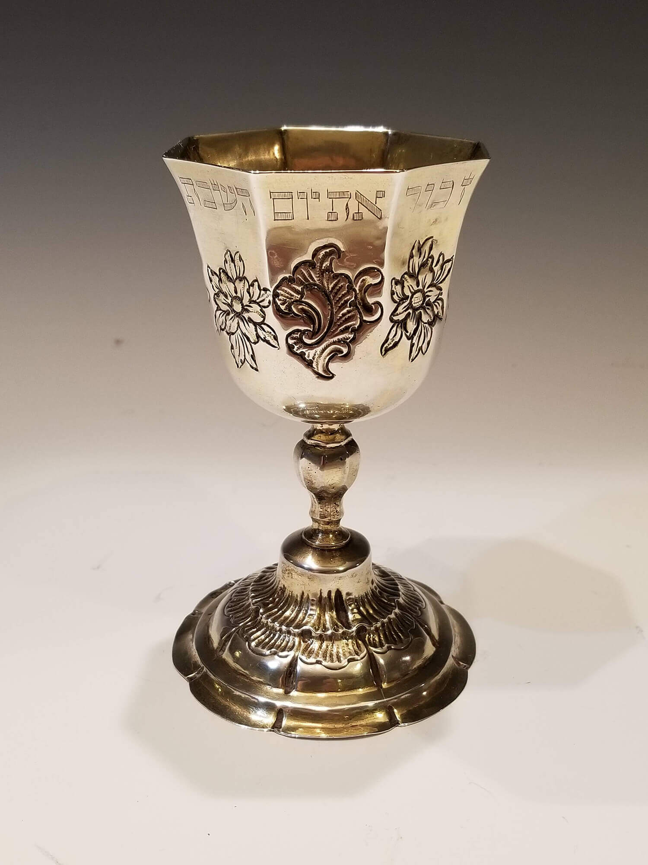

An important parcel gilt Sabbath goblet by Heironymus Mittnacht. Augsburg, 1763 – 1765. On stylized round base with baluster shaped stem and eight-sided goblet portion engraved with biblical commandment to remember and keep the Sabbath. Heironymus Mittnacht was the son of Johann Mittnacht. Provenance:

***Reprinted from the website of J Greenstein & Co., Inc. – specializing in Antique Jewish Ritual Objects and Art.***